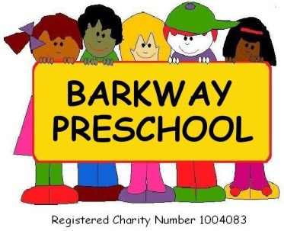

Newsletter Autumn Term (1) 2023

We have been busy over the last couple of weeks getting to know our new starters, settling them in and welcoming back our older children. We would like to welcome to preschool Oscar N, Hunter, Primrose, Sybbie, Margot, Yuna, Matthew, Milo, Lewis and Henry.

**A Very Big Thank You**

All the staff would like to say a big thank you for all our end of term gifts and lovely cards with such heartwarming messages – they were very much appreciated – Thank You 😊

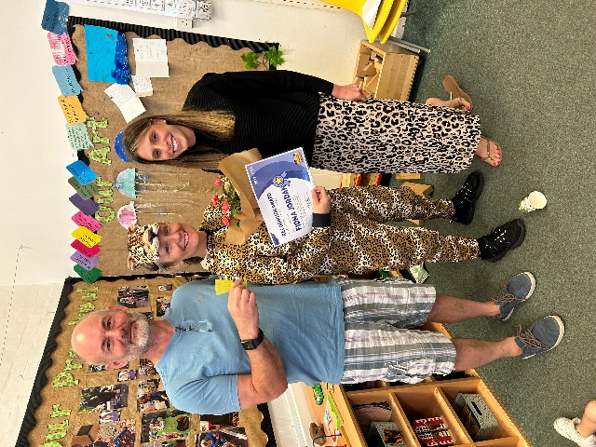**Staff News**

Our “Practitioner of the Year” award this year was won by our lovely Fiona Jordan – thank you for all your votes and well done Fiona.

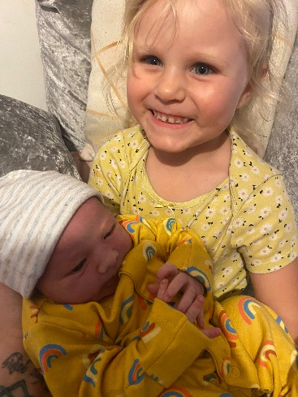

Em who left us at Easter to go on maternity leave gave birth to a bouncing baby boy on Sunday 18th June called Albie – congratulations Em.



[This Photo](https://www.deviantart.com/gurugrendo/art/Chef-Hat-Vector-216474604) by Unknown Author is licensed under [CC BY-NC-ND](https://creativecommons.org/licenses/by-nc-nd/3.0/)

**Creative Chefs**

We will be welcoming Angie from Creative Chefs to preschool on Friday 22nd September and Wednesday 27th September for some fun cooking sessions with the children. Creative Chefs is designed to encourage children to eat seasonal healthy ingredients through fun cooking sessions. All the recipes are child friendly and use accessible ingredients. During a session the children (chefs!) will create a main recipe. In the session Angie will talk about the importance of eating a rainbow diet, we will practise counting skills to the number 3, use vocabulary to describe colours, the feel and the taste of the ingredients. During the session there are ALOT of tasting opportunities!!

**Committee**

Barkway Preschool is a Committee led preschool and without your support in joining the Committee we could not operate. If you would like to volunteer to be a part of our Committee please let a member of staff know or email Katie Linard at [Committee@barkwaypreschool.co.uk](mailto:Committee@barkwaypreschool.co.uk) or Charlotte Garratt at [leader@barkwaypreschool.co.uk](mailto:leader@barkwaypreschool.co.uk).

**Barkway Preschool Library**

We will be starting up a Barkway Preschool Lending Library over the next couple of weeks and encourage you to choose a book with your child each week, take it home, share it with your child and then return it when you are finished with it. Reading with your child is the first step towards reading and is vital for children in their early years. It is not only important for their development and education it is also good for your child’s wellbeing and for building relationships. Look out for the Library Box outside preschool.

**Barley Barkway Open Morning**

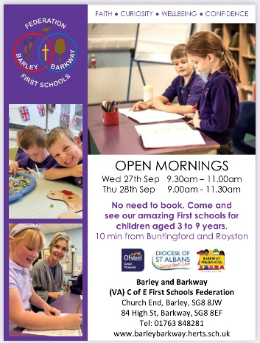We are joining Barley Barkway Federation for their open mornings on Wednesday 27th September - 9:30am-11.00am and on Thursday 28th September 9.30am – 11.30am.

Come along and have a look around their school if you are considering applying for a Nursery or Reception place in 2024.

Also if you know someone who is looking for a preschool place from September 2024 tell them to come along for a visit - there is no need to book.

**Fee Increases**

As you are aware our fees increase on 1st September to £5.75 per hour – if you are struggling with the increase please do not hesitate to contact us we do not want you to suffer in silence and there are ways that we can help.

**Drop off and Pick Ups Times**

Just a quick reminder that our drop off and pick up times are as follows:

Early Starts: 8.15am

Preschool Session Start: 9am

Preschool Session Finish: 12pm

Lunch session: 12pm-1pm

Afternoon session: 1pm – 3pm

Late Pick ups – 3pm – 4.15pm

Please refrain from ringing the doorbell unless it is an emergency as this really unsettles some of the children.

**Snacks**

We are trialling a fruit only snack in preschool for the morning and afternoon sessions – we found that children were eating too much of the carbohydrate snack and not the fruit and then and not eating their lunch last term. Those children who stay for the late pick ups will be offered a carbohydrate snack to see them through to tea time. Having just fruit at snack time also prepares them for when they move on to school.

If we find that children are not joining in with snack and going hungry we will review the situation but currently they are enjoying it.

If your child is not keen on fruit and you would like them to have a snack from home please provide them with a small healthy snack (no more than 1 item) from home to accompany the fruit we offer.

We continue to offer the children a choice of milk and water at each snack time and water throughout the day.

**Pick up times**

We realise that pick up times can seem rushed and very miltary but we try and accommodate all parents wishes for picking up quickly as they have other pick-ups/work committments after preschool pick ups but if you would like a more indepth handover at the end of a session please say so and we can accommodate this once all the children who are leaving the session have left. Our door is always open if you need to discuss how your child’s session has been, whether you have any concerns with any aspect of your child’s development or just wish to have a catch up.

Don’t forget that you can use Tapestry and email to contact your key person too if you need to speak to them.

**Brilliant Box**

Last year the children really responded well to receiving Wow straws and we have slightly tweeked it this year and we now have a “Brilliant Box”. This is more visual for the children. The Brilliant Box is a reward system where children can earn a pom pom to go in the Briliant Box when they have done a good deed in preschool – this can be for great tidying up, being friendly and helpful, listening at story time, great singing, they may even get one for having a go on the toilet or potty or trying something different at snack time too. Once our Brilliant Box is full we give the children a treat – this can be longer playing time, parachute play, a disco at story time, or a mini party with party games. The children love earning their pom poms and enjoy the reward even more.

**Family Photo Books**

We would love for all children to have a small photo book of the people, items and pets that are special to them in preschool to help when they are settling in or need a little bit of comfort. The children also love to share their photo books with other children in the setting too. All the big photo companies sell them or you can make your own with your child or you could pop photos on Tapestry and we can print them and make one for you. Don’t forget to add titles of the people, pets or special items so we can talk to the children about them too. If you would like to see a sample on just ask a member of staff.

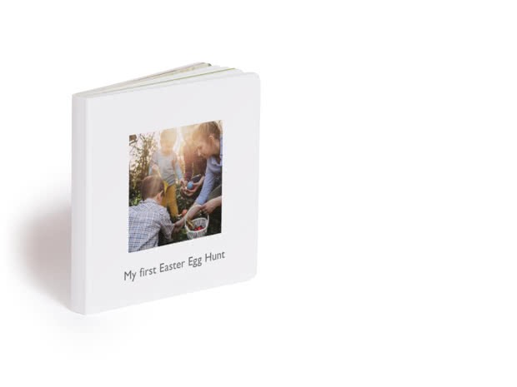Example:

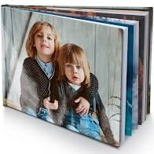 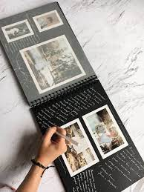 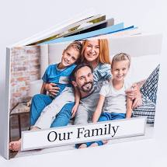

**Facebook and Instagram**

Don’t forget to join our closed Barkway Preschool parent pages which is different from our main page – this has up to date information/messages.

**Tapestry**

Please ensure your account is active and checked regularly as we use the “memo” function to contact parents/carers more than we use email. Also, on Tapestry you can find all our policies and procedures, newsletters and every day documentation. Please also don’t forget we love to see photos of experiences the children have had at home so add observations – if you are not sure how to do this just ask**.**

**Uniform**

Uniform is available to purchase – if you are interested please let us know as soon as possible as an order is about to be placed for new stock

**Illness**

In order to keep illnesses away from preschool as much as we can we askthatif you feel that your child is not well enough to attend preschool and join in the routine of the day, if you have had to administer Calpol or Ibuprofen you do not send them in to preschool. Allow 48 hours before they return after the last dose of medication or symptom.

If your child starts a course of medication such as antibiotics after being un-well please also allow 48 hours after starting this medication before they return to preschool.

If your child has a sickness and/or diarrhea bug they must be absent from preschool for a minimum of **48 hours** after the **last** bout of sickness and/or diarrhea.

We thank you in advance of your cooperation to keep preschool bug free!

**Reporting an Absence from Preschool**

Please **telephone/text** Preschool and advise us of **any** absence on 07964 151288. We prefer a telephone call/text as we do not always check our preschool email while the preschool is in session.

**Outside play**

Make sure your child has appropriate clothing for the time of year. **Please also ensure that all clothing/shoes/wellies are all clearly labelled**.

We ask that you also check your child’s spare clothes bag regularly to make sure that the clothes still fit and are weather appropriate.

**Lunchbox Reminders**

Lunchboxes need to be in wipeable plastic boxes (sorry no fabric lunch bags) and clearly labelled. We ask that you do not include any foods containing **nuts**. This includes spreads, pesto, cereal bars, homemade cakes, etc.

To avoid the possibility of your child choking on foods, such as grapes, olives, cherry tomatoes, mini sausages etc., please ensure that these are cut in half, length ways and grapes should be cut into quarters**.**

If your child has a yoghurt in their lunch please also send in a spoon so they can use it to eat the yoghurt.

Please do not include sweets, chocolate or fizzy drinks - keep these as a treat for home.

**Water Bottles**

Please can you ensure that water bottles only contain water and not juice and is clearly named. Also please ensure your child’s water bottle is cleaned daily too.

**Easy** **Fund** **Raising**

Please support Barkway Preschool on #easyfundraising, you can raise FREE donations when you shop online with over 5,000 retailers. John Lewis & Partners, Argos, notonthehighstreet and many more are ready to give us FREE donations. It's simple and only takes 2 minutes to sign up! Right now, every donation makes a difference! Sign up here: <https://www.easyfundraising.org.uk/causes/barkwaypreschool/?referral-campaign=c2s&utm_source=refsharebox>

**Comments and Suggestions**

We always welcome any comments and suggestions you have with regards to the preschool. We are happy to receive these in person, or email Charlotte at [leader@barkwaypreschool.co.uk](mailto:leader@barkwaypreschool.co.uk)

If there is anything else Preschool can help with please do not hesitate to ask.

**Dates for your diary:**

|  |  |
| --- | --- |
| Inset Day: | 1st September 2023 |
| Autumn Term Starts | 4th September 2023 |
| Open Days: | 27th September 2023 9.00-11am  28th September 2023 9.00am – 11.30am |
| Half Term: | 23rd – 27th October 2023 |
| Children Return: | 30th October 2023 |
| Occasional Day (preschool closed) | 1st December 2023 |
| Term Finishes for Christmas: | 20th December 2023 @ 1pm |
| Spring Term Starts: | 8th January 2024 |