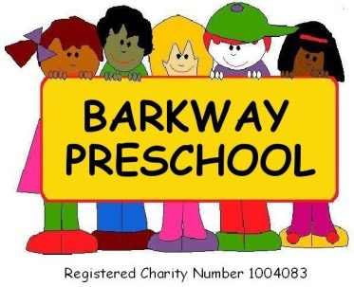
Newsletter Spring Term (1) 2023
Welcome to our New Starters this half term.
Thank you for all your kind Christmas wishes, gifts and cards we were all very touched by your kindness and generosity. We are all looking forward to meeting and getting to know our new starters, Jude, Tiffany and Finley - welcome to Barkway Preschool.
Our focus this term.
This term we will be exploring healthy minds and bodies along with a healthy planet.
Staff News
We are delighted to welcome to our team Liz Tansley who joins us as a Level 3 Practitioner with a wealth of experience in early years. She is looking forward to working with all the children in preschool and especially her new key children.
Early Drop Offs (8.15am) / Late Pick Ups (4.15pm)
Dont forget we are offering early drop offs and late pick ups – if you would like to book these – even if add hoc – please let us know by emailing leader@barkwaypreschool.co.uk.
New Committee Members
You will have seen from the Committee Newsletter that Katie Linard and Ella Williams have joined the Committee as Chair and Secretary ensuring that our preschool can continue to operate. We are all excited to welcome them aboard and look forward workng with them.
First Fund Raising Event of 2023
The Committee’s first fund raising event for preschool will be on Thursday 19th January for “World Popcorn Day” the Committee will be selling popcorn outside of preschool for £1.00.
Cost of Living
We know that it is a very worrying time for parents and carers at the moment and if you are in any way struggling please do not hesitate to come in and talk to us so that we can try and help. Our door is always open.
Uniform
If you would like your child to have a preschool uniform we have items in stock to buy – just ask a member of staff.
Pick Up and Drop Off Times
We ask that you keep to your pick up and drop off times as we need to keep our ratios correct and cause as little disruption to the routine of the day. If you are running late please text/call the preschool to inform them of this.
Family Photo Books
A very big thank you to all the parents who have provided photo books for their child. The children are loving looking at them. We would love for all children to have a small photo book of the people, items and pets that are special to them in preschool. All the big photo companies sell them or you can make your own with your child or you could pop photos on Tapestry and we can print them and make one for you. Don’t forget to add titles of the people, pets or special items so we can talk to the children about them too.
Examples:
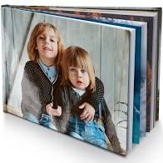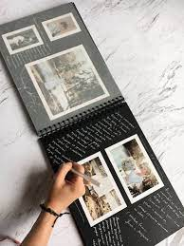

Facebook
Don’t forget to join our closed Barkway Preschool parents page which is different from our main page – this has up to date information/messages. Also we are working on an Instagram account so keep an eye out for this over the coming weeks.
Tapestry
Please ensure your account is active and checked regularly as we use the “memo” function to contact parents/carers quickly.
COVID-19, Flu and Scarlet Fever and other Illnesses
Please be extra vigilant with your child’s health – Covid-19, Flu and Scarlet Fever are on the rise in our area and so that we can keep illnesses away from preschool as much as we possibly can we ask that if your child is not well enough to attend preschool, especially if you have had to administer Calpol or Ibuprofen which could mask symptoms of illnesses you do not send them in. Please allow 48 hours before they return to preschool after their last symptom / medication. Also if your child has a sickness and/or diarrhea bug they must be absent from preschool for 48 hours after the last bout of sickness and/or diarrhea.
Reporting an Absence from Preschool
Please telephone/text Preschool and advise us of any absence on 07964 151288. We prefer a telephone call/text as we do not always check our preschool email while the preschool is in session.
Outside play
Make sure your child has appropriate clothing for the time of year – we go out in all weathers. Please also ensure that all clothing/shoes/wellies are all clearly labelled.
Please check your child’s spare clothes bag regularly to make sure that the clothes still fit and are weather appropriate.

Spare Clothes
Please ensure your child has a change or two of clothes in their bags, also if your child goes home in preschool clothing could you please ensure that they are washed and returned as stocks are running low and on occasions we run out items.
Snack and Lunchbox Reminders
Snack / Lunch boxes need to be in wipeable plastic boxes (sorry no fabric lunch bags) and clearly labelled. We ask that their snack / lunch is a healthy snack / packed lunch and that you do not include any foods containing nuts - this includes spreads, pesto, cereal bars, homemade cakes, etc. Also, to avoid the possibility of your child choking on foods, such as grapes, olives, cherry tomatoes, mini sausages etc., please ensure that these are cut in half, length ways and grapes should be cut into quarters.
Please do not include sweets, chocolate or fizzy drinks - keep these as a treat for home.
Water Bottles
Please can you ensure that water bottles only contain water and not juice and is clearly named. Also please ensure your child’s water bottle is cleaned daily too.
Cash in preschool
We are a cashless preschool so if you need to pay preschool please transfer the money into the account below.
HSBC Bank
Account name: Barkway Playgroup
Sort Code: 40-39-22
Account Number: 01316281

Easy Fund Raising and Amazon Smile
Please support Barkway Preschool by using #easyfundraising, you can raise FREE donations when you shop online with over 5,000 retailers. John Lewis & Partners, Argos, notonthehighstreet and many more are ready to give us FREE donations. It's simple and only takes 2 minutes to sign up! Right now, every donation makes a difference! Sign up here: https://www.easyfundraising.org.uk/causes/barkwaypreschool/?referral-campaign=c2s&utm_source=refsharebox
You can also join AmazonSmile to support us with every purchase, to do this log on to your account and add Barkway Preschool as your chosen charity. Amazon donates 0.5% of the net purchase price of eligible purchases to Barkway Preschool. All you need to do is log on to Amazon, go to your account click on Amazon Smile then select Barkway Preschool
Comments and Suggestions
We always welcome any comments and suggestions you have with regards to the preschool. We are happy to receive these in person, or email Charlotte at leader@barkwaypreschool.co.uk
If there is anything else Preschool can help with please do not hesitate to ask.

Dates for your diary:
Spring Term (1) Starts | 6th January 2023
World Popcorn Day | 19th January 2023
Half term starts: | 13th February 2023
Spring Term (2) Starts: | 20th February 2023
Spring Term (2) Finishes: | 30th March 2023

